**Four phases of Automated Test**

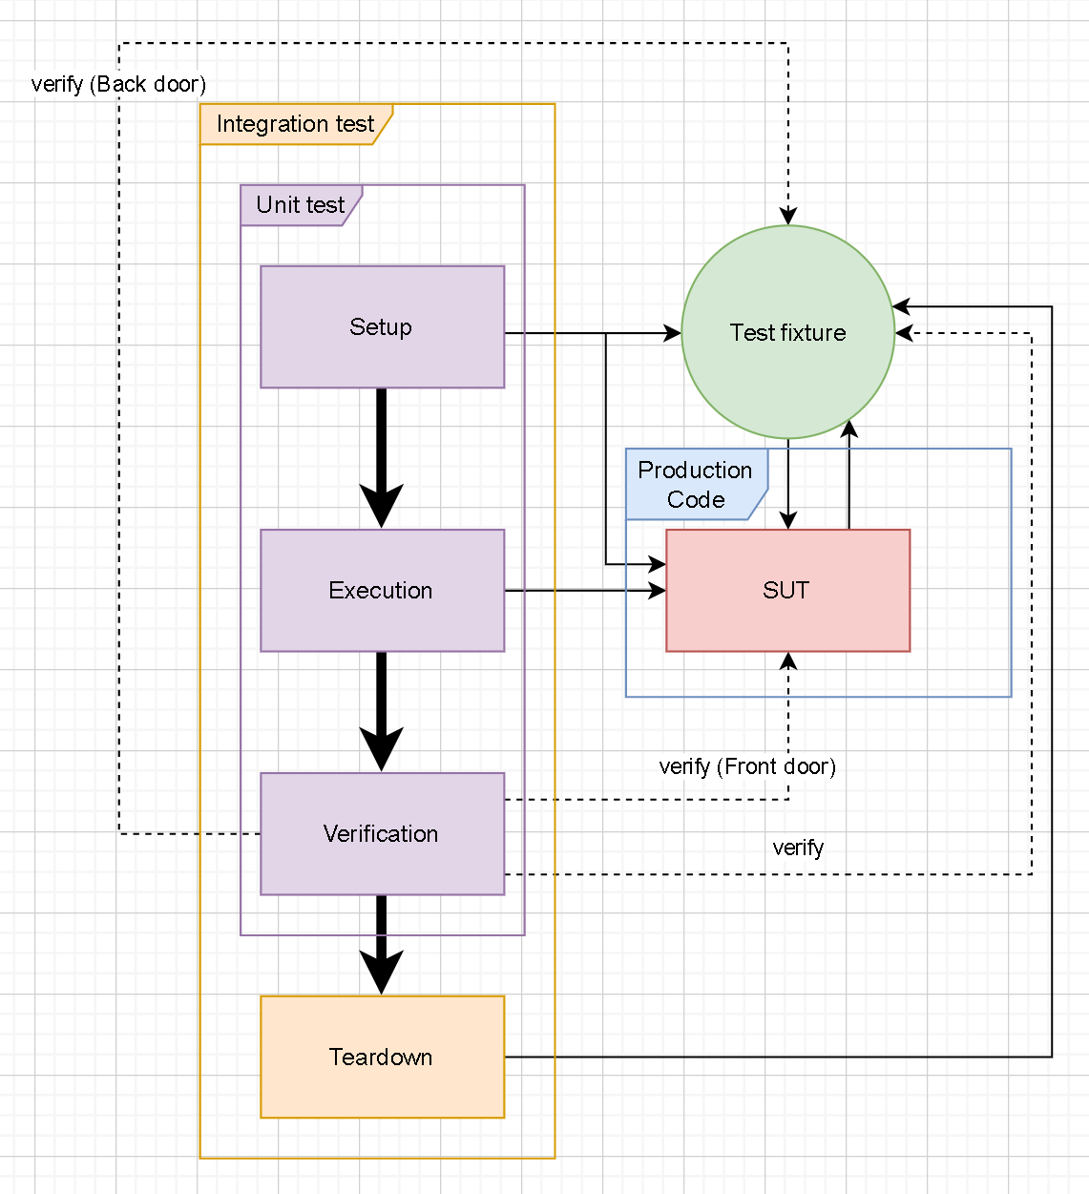

**Terminology:**

**SUT**: System Under Test

**Test fixture**: SUT dependencies (environment)

**Phases:**

**Setup:** create/find SUT or Test fixture

**Execution**: execute something on SUT.

**Verification**: verify state or behavior of SUT/Test fixture.

**Teardown**: clean up after test.

**Unit Test Tools**

**Test Framework**: xUnit (<https://xunit.net/>)

**Test Fixture**: Moq (<https://github.com/devlooped/moq>)

**Test Verification**: Fluent Assertions (<https://fluentassertions.com/>)

**Test Runner**: Visual Studio, SonarQube Build Pipeline

**Test Quality**: Code Coverage

**Unit Test Project Hierarchy**

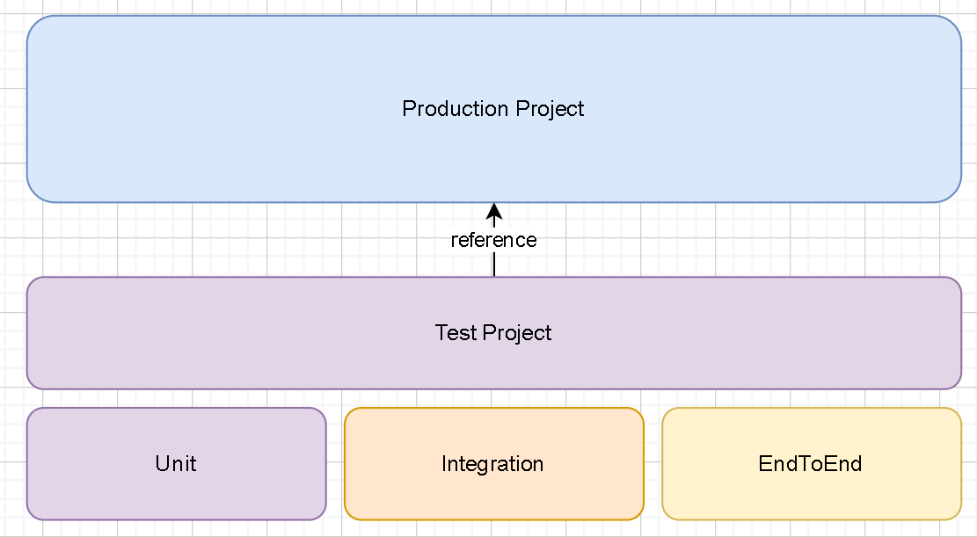

**Code**

Production project

Test project

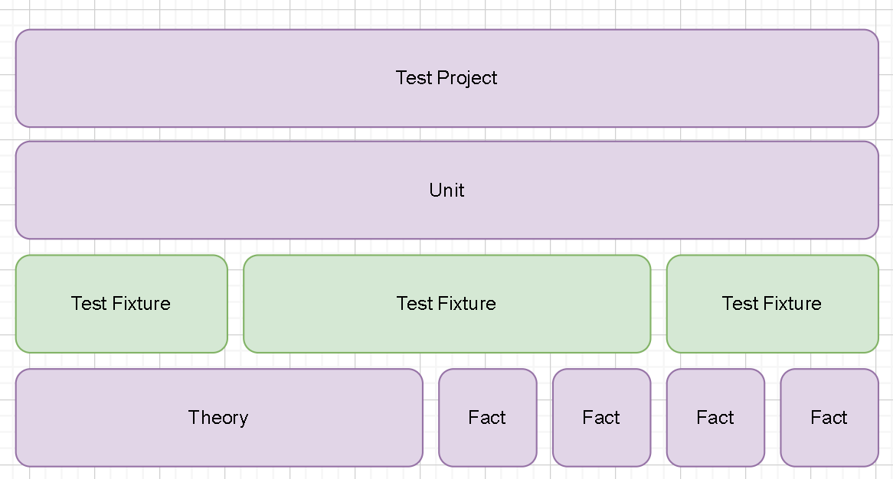

**Code**

Test project

**Unit Test Best Practices**

Consistent

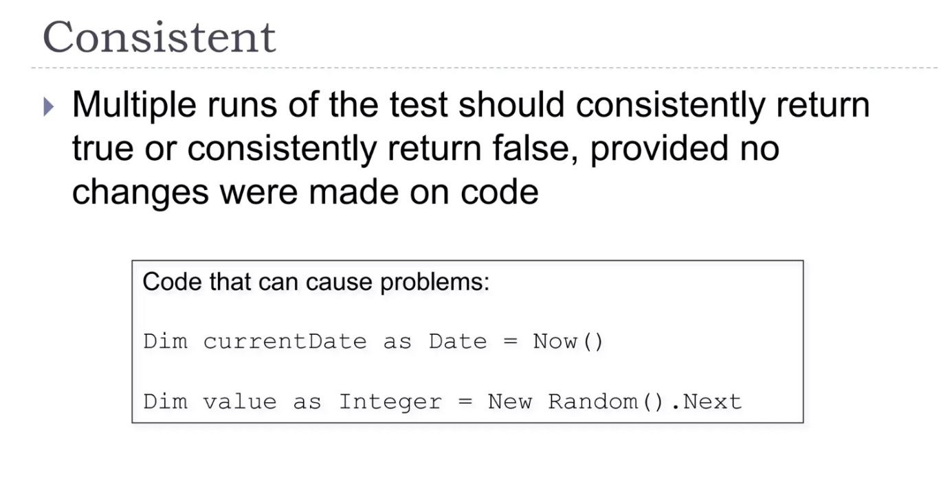

Atomic

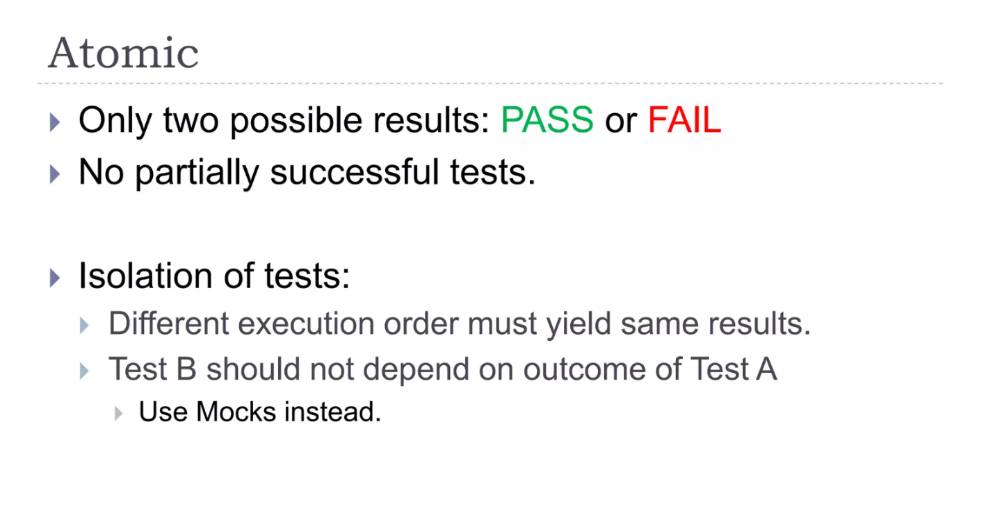

Single Responsibility

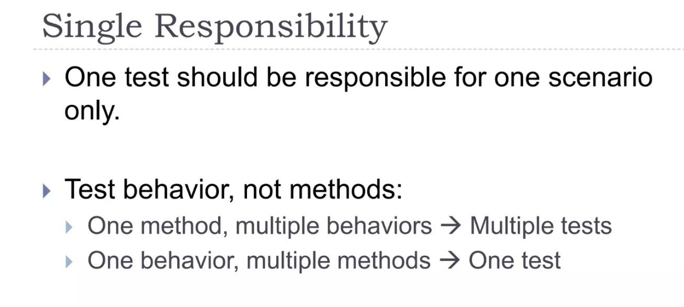

Self-descriptive

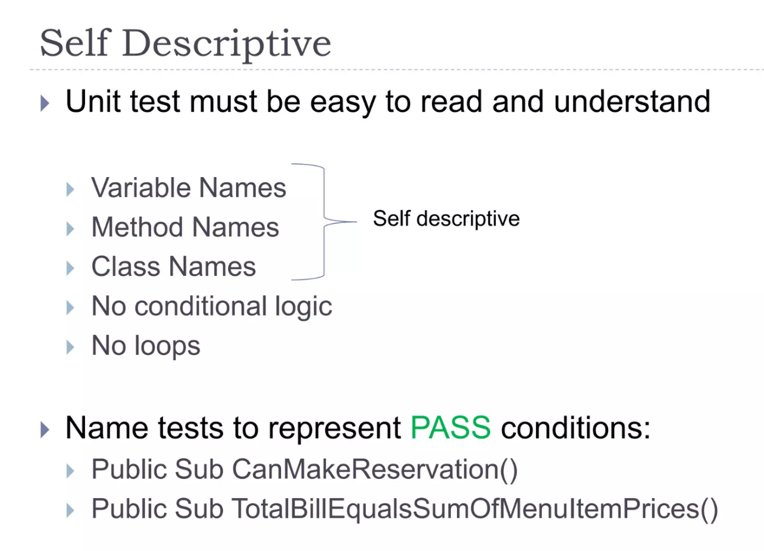

No conditional logic or loops

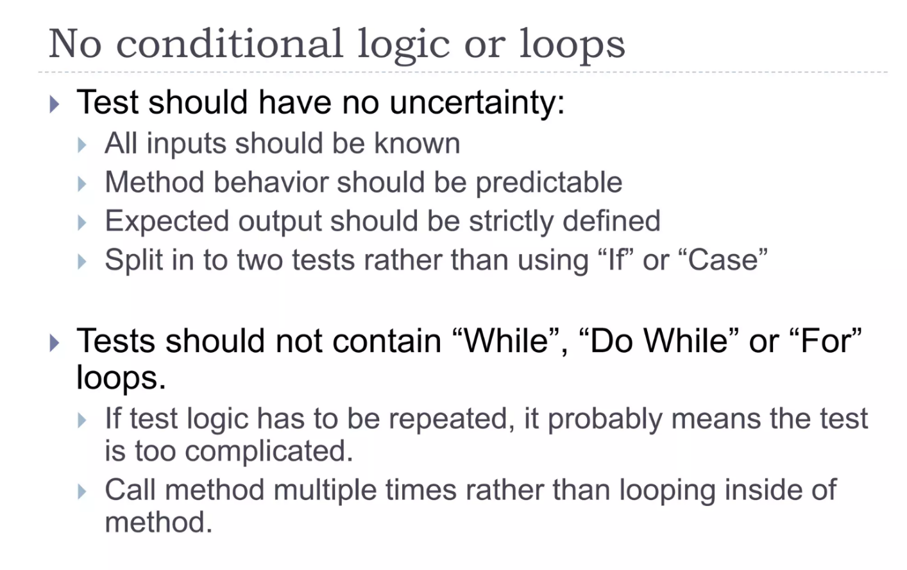

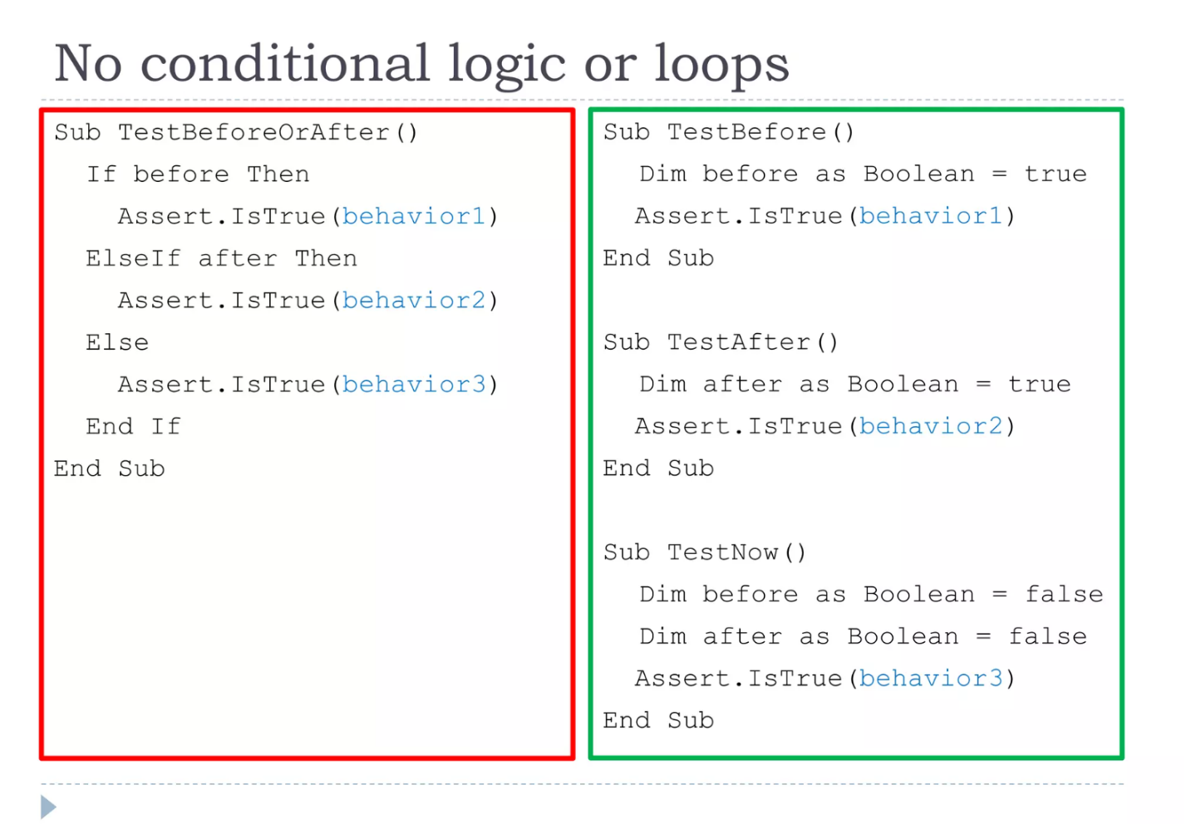

No exception handling

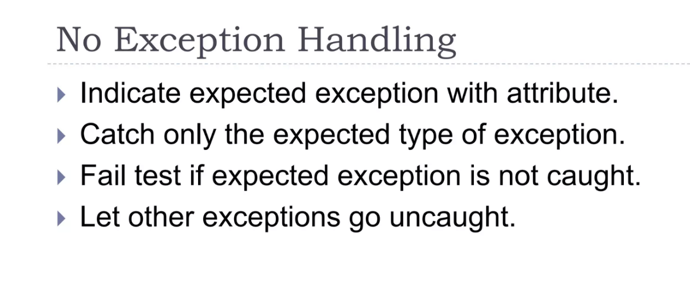

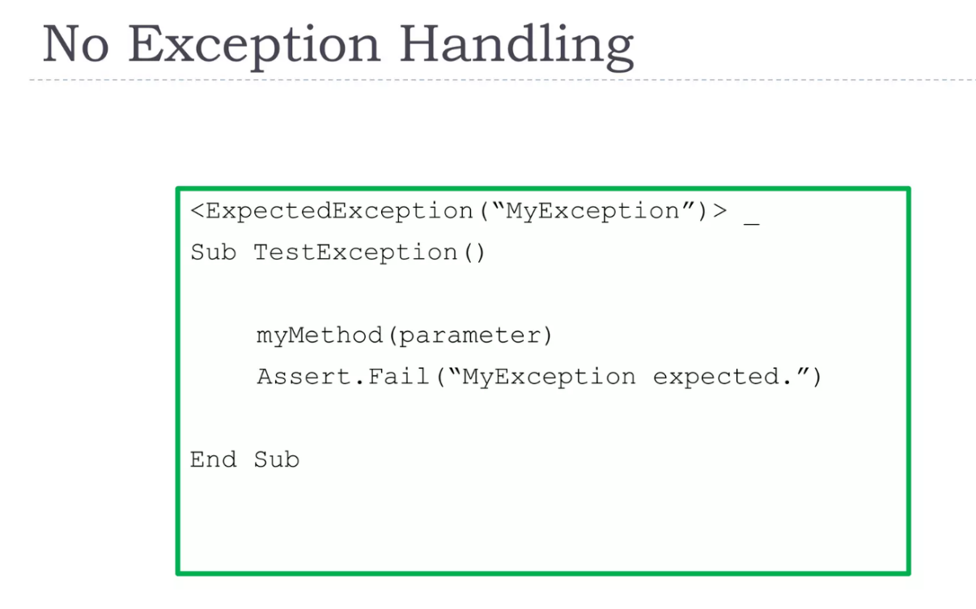

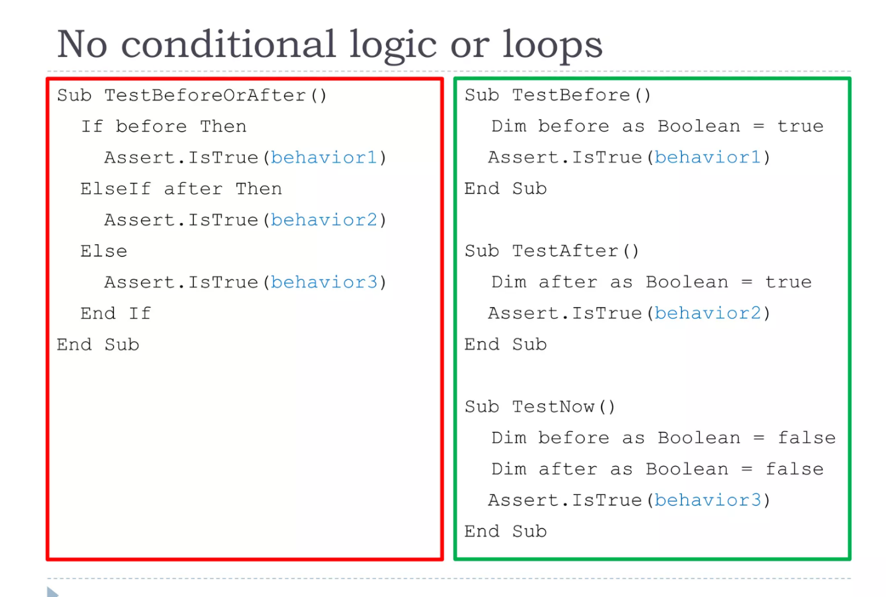

Informative Assertion messages

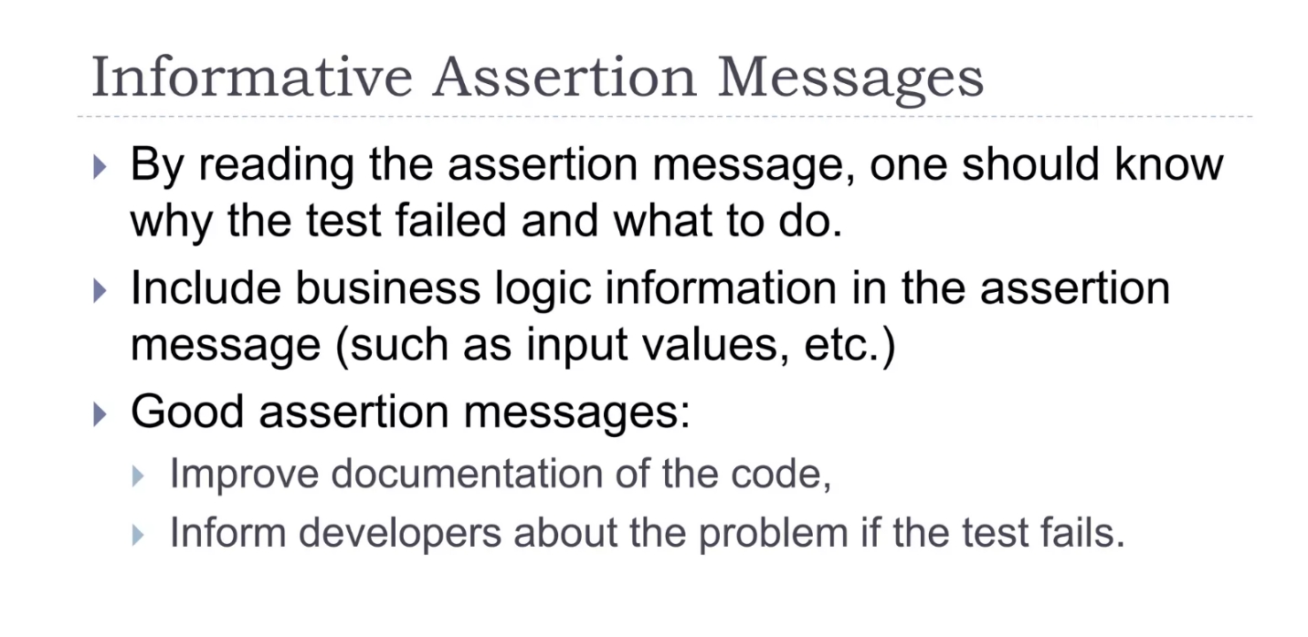

No test logic in production code

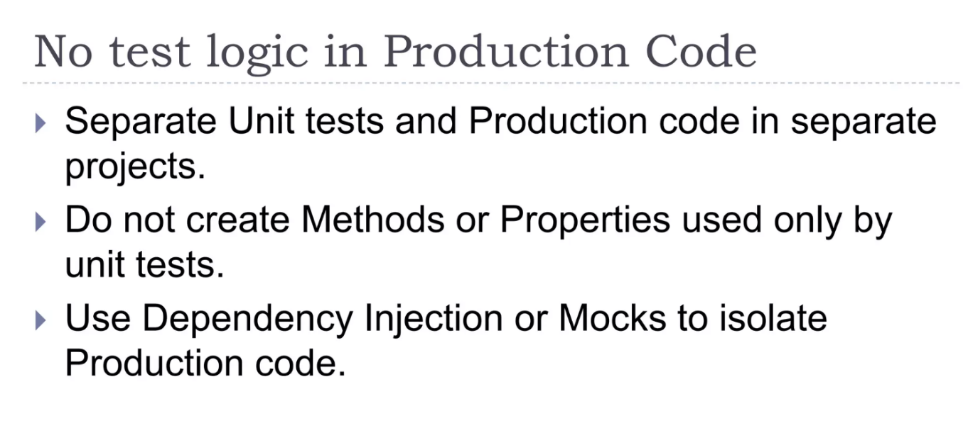

Separation per business module

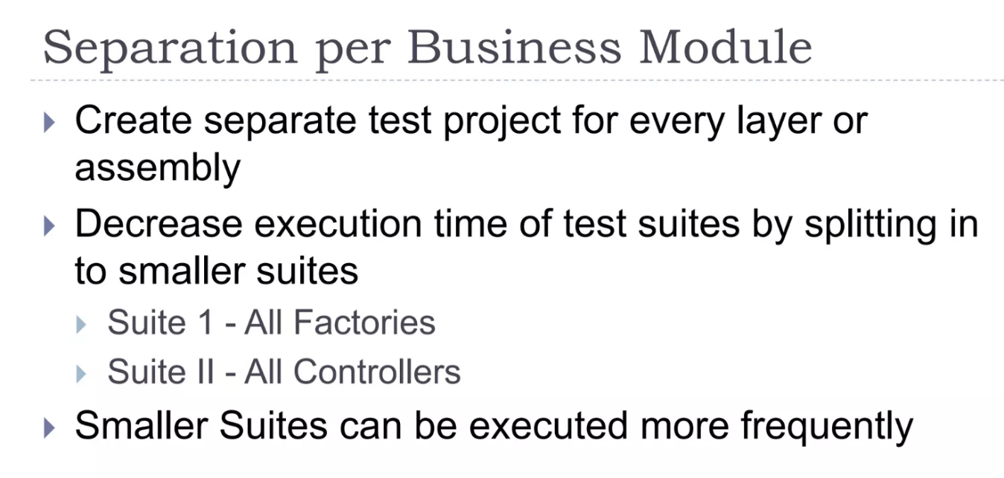

Separation per type

